Title:Do fungal infections are the cause of allergic fungal rhinosinusitis among patients with nasal polyposis?
Name:
Ramadan Hashem Sayed (M.D.)
Professor of ENT, Sohag Faculty of Medicine, Sohag University, Egypt.

Noha ED Hassab El-Naby
Lecturer of Pathology, Sohag Faculty of Medicine, Sohag University, Egypt.

MarwaSaadbadryabbas
Resident doctor in ENT department, Sohag Faculty of Medicine, Sohag University, Egypt.

Running title: Sayed RH and Noha ED: AFRS among nasal polyposis.
Address for correspondence:
Noha ED Hassab El-Naby
Sohag Faculty of Medicine, Sohag University, Egypt.
E-mail: noha_eldabie@yahoo.com
Tel: 01010308054
Fax: 0934602963

Abstract:
Introduction: Allergic fungal rhinosinusitis (AFRS) is a noninvasive type of fungal rhinosinusitis (FRS) that is diagnosed by fulfilling five diagnostic criteria: type I hypersensitivity, nasal polyposis, characteristic findings on CT scan, presence of fungi on direct microscopy or culture, and allergic mucin containing fungal elements. Objectives: This work aimed to study the fungal etiology of AFRS and to evaluate the prevalence of AFRS among patients with CRS with nasal polyposis (CRSwNP) that underwent endoscopic sinus surgery (ESS) at Sohag University Hospital. Patients and Methods: A prospective study involved all patients presented to Otorhinolaryngology Department, Sohag University Hospital, Sohag, Egypt, with nasal polyposis and who were candidate for ESS during the period from December 2015 to December 2016. A detailed history was taken, full E.N.T examination and CT scans were done to all patients who underwent ESS. Histopathological examination of the removed polyps and eosinophilic allergic mucin (AM) was done using hematoxylin& eosin (H&E), periodic Acid schiff (PAS) and Gomorimethanamin silver (GMS) stains.Statistical analysis was carried out with the Statistical Software Package Standard (SPSS). Results: In 17/61 patients, AM was detected, 12/61 of them (19.7%) showed no fungal hyphae and were diagnosed eosinophilic mucinrhinosinusitis (EMRS). In the remaining 5/61 (8.2%) cases AM and fungal hyphae were seen and diagnosed as AFRS. 41/61 (67.2%) patients didn't show neither AM nor fungal hyphae and diagnosed as CRSwNP. In 2/61 (3.3%) we detected fungal hyphae both on the surface of polyp mucosa and invading the tissue of the nasal polyps and diagnosed as chronic invasive fungal rhinosinusitis (CIFRS) and the remaining one patient (1/61=1.6%) was diagnosed to have inverted papilloma. Conclusion: No significant association between AM and fungal hyphae, only 5/17 (P=0.09) patients with AM fulfill the diagnostic criteria of AFRS. The presence of AM is not unique to AFRS, but rather is the result of a process that could have other etiologies. AFRS is more appropriately termed allergic mucinous sinusitis or eosinophilic mucinous rhinosinusitis.
Keywords: fungus; nasal polyp; prevalence; sinusitis.

Introduction:
Fungal rhinosinusitis (FRS) is classified into two subgroups, invasive and noninvasive, with three invasive forms (acute necrotizing, chronic invasive, granulomatous invasive), and two noninvasive forms (fungal ball and allergic fungal rhinosinusitis).[1] Acute invasive sinusitis,also referred to as fulminant invasive fungal sinusitis, is often seen in immunocompromised patients. Vascular invasion by fungi may result in mycotic thrombosis, and usually after presentation with ocular involvement, intracranial extension, or both, patients follow a downward-spiraling course with rapid deterioration, often resulting in death. Chronic invasive fungal sinusitis, also known as indolent fungal sinusitis, is often seen in diabetic patients, immunocompetent individuals, and in endemic areas such as The Sudan and Saudi Arabia. The histologic features are usually a collection of organisms with a surrounding granulomatous, foreign body inflammatory response and demonstrable hyphae invading tissue. The designation of invasion rests on both morphologic evidence of tissue invasion and radiographic demonstration of bony erosion. This form of sinusitis distinctly lacks evidence of vascular invasion by fungi, as seen with the acute fulminant type of infection. The fungal ball (mycetoma) is an extramucosal collection of hyphae, usually in the maxillary antrum, which provokes little or no host response. It is seen in immunocompetent individuals who may have a prior history of sinus disease, trauma, or a foreign body.[2]
Allergic fungal rhinosinusitis can be distinguished clinically and histopathologically and there are current strategies for treatment compared to other forms of FRS. It may represent an allergic hypersensitivity response to extramucosal fungi within the sinus cavity. Affected patients are usually young, immunocompetent, atopic and initially present with nasal polyps. Patients often have asthma, aspirin-sensitivity, allergic rhinitis, and eosinophilia.[1] The pathogenesis of AFRS, particularly its similarity to allergic bronchopulmonaryaspergillosis (ABPA), has been presumed to be a combination of types 1 and 3 hypersensitivities to fungal allergens.[1] This supposition was enforced by elevated fungal-specific immunoglobuline E (IgE) and IgG antibodies.[3] However, the overall immunological mechanisms of AFRS are currently considered to be more complicated. The incidence of AFRS was estimated at 5 to 10% of all CRS who underwent sinus surgery.[4,5] In India, the incidence was 83.9% in patients with nasal polyps.[6] The incidence variability may depend on geographical variation and problems in diagnosis of the disease.[7] Although there are physical findings, laboratory test results, and CT scan showing evidence of CRS, the histopathological examination of surgical sinus specimens is diagnostic for AFRS.[1] Histopathology shows inflammatory tissue, frequently accompanied by eosinophilia and extramucosal AM. Fungal stains are positive for hyphae within the AM but not invading the mucosa. Fungus may be hard to find within the AM and the tissue. Therefore, this led to the definition of a new entity: eosinophilic mucinrhinosinusitis (EMRS).[8] Previous reports in the literature had alluded to this entity and had described it variously as “AFS-like syndrome” or “allergic mucin sinusitis without fungus”.[1]
To diagnose AFRS, Bent and Kuhn in 1994,[9] proposed five diagnostic criteria: type I hypersensitivity, nasal polyposis, characteristic findings on CT scan, presence of fungi on direct microscopy or culture, and AM containing fungal elements without tissue invasion. In 1994, Cody II et al.,[9] reported the Mayo Clinic experience and suggested that diagnostic criteria comprise only the presence of AM and fungal hyphae or a positive fungal culture. The criteria for diagnosis of AFRS had undergone numerous revisions; however, most authors agree on thefollowing: the presence in patients with CRS (confirmed by CT scan) of characteristic AM containing clusters of eosinophils and their byproducts and the presence of noninvasive fungal elements within that mucin, detectable on staining or culture.[10] Most experts also required the presence of documented type 1 (IgE-mediated) hypersensitivity to cultured fungi and nasal polyposis.[10] There are no clear diagnostic criteria to establish the diagnosis of AFRS. With the description of newer categories like eosinophilic FRS and EMRS, it has become more difficult to establish criteria for diagnosis. The laboratory findings in the possible AFRS groups are quite variable and are a source of controversy.[11]
The aim of this study was to study the fungal etiology of AFRS and to investigate the prevalence of AFRS among patients with CRS with NP who underwent endoscopic sinus surgery (ESS) in Sohag University Hospital.

Patients and methods:
This is a prospective study, complies with the ethical standards of the relevant regional and institutional guidelines on human studies, Sohag Faculty of Medicine, Sohag, Egypt. Informed and written consent was taken from all participants. The study involved all patients presented to Otorhinolaryngology department, Sohag University Hospital, Sohag, Egypt, with nasal polyposis and who were candidate for ESS during the period from December 2015 to December 2016. A detailed history was taken including history suggestive of associated co-morbidities like bronchial asthma.Full E.N.T examination, sinoscopic examination and CT scans were done to all patients.All these patients underwent ESS to remove nasal polyposis, diseased tissues, and AM from involved sinuses and to establish sinus areation.
Histopathological evaluation:
Histopathologic evaluation was done in the Pathology Department, Sohag University Hospital, Sohag, Egypt. The biopsy materials included tissues with mucus that was manually removed during ESS and not placed directly on a surgical towel or gauze to prevent absorption. The material obtained was fixed in 10% formalin, processed and 5 micron thick sections were cut from paraffin blocks and stained with hematoxylin& eosin (H&E), periodic Acid schiff (PAS) and Gomorimethanamin silver (GMS) stains. The staining procedures were conducted according to the stains associated staining sheets. The slides were examined for detection of extramucosal AM, Charcot-Leyden crystals, fungal hyphae, and mucosal invasion by fungal hyphae.
Statistical analysis:
Statistical analysis was performed by SPSS software (version 17). Continuous variables are presented as mean ± SD, and categorical variables are presented as absolute numbers and percentages. Categorical variables were analyzed using the chi-square test or Fisher’s exact test as appropriate. Values of p<0.05 were considered significant.

Results:
The study included 61 cases with age range 7-75 years, and the mean age+SD was 29.64+1.26. The highest prevalence of the disease (19=31.1%) was in the age group 30-40 years. Among our patients, nasal polyposis were more common in males (35=57.4%) than females (26=42.6%), and more common among those came from rural areas (37=60.7%) than urban ones (24=39.3%). We detected bilateral nasal polypi in 49 (80.3%) of cases and recurrent polyposis constituted 23% (14/61) of our patients. Twelve patients (19.7%) had associated bronchial asthma. CT scanning revealed double density sign, an evidence suggestive of AFRS, in 21/61 (34.4%) of our cases, while bone erosion was seen in 14/61 (23%) cases, 12 of them (85.7%) had eosinophilic mucin during ESS.
At surgery, AM was grossly detected in 17/61 cases (27.9%), all of them had double density signin CT that raised the suspicion of AFRS. Demographic, clinical, and radiological criteria of these cases are listed in (table 1). Histopathological examination of this AM revealed inspissated laminated basophilic, purple-colored mucous with large numbers of degenerated eosinophils, sloughed epithelial cells and occasional Charcot-Leyden crystals (figures 1a, b).
Histopathological examination of 61 cases using H&E, PAS and GMS stains classified the patients into 5 categories (table 2): 12 patients (19.7%) showed the microscopic picture of AM with no fungal hyphae and diagnosed to have EMRS. Five cases (5/61=8.2%) had AM and fungal infection in the form of fungal colonies detected in the AM (figure 2) or superficially on mucosal surface that confirmed the diagnosis of AFRS.The association between AM and fungal hyphae was statistically insignificant (P=0.09). Forty one patients (41/61= 67.2%) showed a ciliated psuedostratified columnar respiratory epithelium with occasional patches of metaplastic squamous epithelium. The submucosa revealed inflammatory infiltrates, usually lymphocytes with occasional lymphoid follicles and plasma cells, edema, mucus plugs and hyperplasia of the mucous secreting glands. In these 41 cases, neither AM nor fungal hyphae were detected (figures 3a, b, c) and thus diagnosed to have CRS with NP (CRSwNP). Among our cases with nasal polyposis, we detected 2 patient (2/61= 3.3%) that showed fungal hyphae both on the mucosal surface and invading the tissue of the polyps with no AM (figures 4a, b, c, d) and diagnosed as CIFRS, and the remaining one case (1/61= 0.016%) revealed the microscopic picture of inverted papilloma (table 2).
Thus, among our cases in whom AM was grossly detected at surgery, 5/17 of them (29.4%) were proved histopathologically to have fungal hyphae, confirming the diagnosis of AFRS, while in the remaining 12/17 (70.6%) we couldn't detect fungal hyphae in the examined specimens and diagnosed as EMRS.
Fungal hyphae were detected in 7/61 cases; 2/7 of them by H&E, and 2/7 cases by PAS (3.3% sensitivity for both). GMS detected fungal hyphae in all the 7 cases in our study (11.5% sensitivity), so GMS is much more superior to the PAS and H&E in the detection of fungal hyphae.

Table1. Demographic, clinical, and radiological criteria of patients with intraoperative detection of AM (n=17):
Variety |  | Number
 | Demographic distribution
Sex | Female | 10 (58.8%)
Sex | Male | 7 (41.2%)
Residence | Rural  Urban | 9 (52.9.7%)  8 (47.1%)
Clinical presentation
Unilateral polyposis |  | 11 (64.7%)
Bilateral polyposis |  | 6 (35.3%)
Associated bronchial asthma |  | 2 (11.8%)
Recurrent cases |  | 5 (29.4%)
Radiologic evaluation
Double density sign |  | 17 (100%)
Bone erosion |  | 12 (70.6%)

Table 2: Histopathological criteria of all patients (n=61):
Variety | Number
CRSwNP | 41 (67.2%)
CIFRSwNP | 2 (3.3%)
EMRS | 12 (19.7%)
AFRS | 5 (8.2%)
Inverted papilloma | 1 (1.6%)

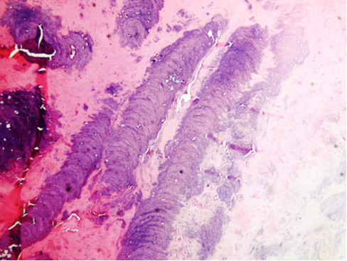
Fig 1a: Allergic eosinophilic mucin showing inspissated laminated basophilic, purple-colored mucous; H&E stain X100.
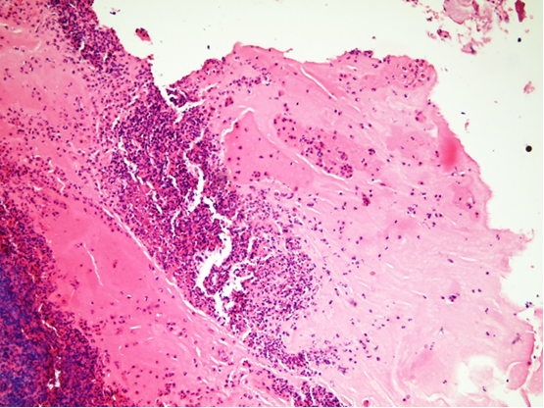
Fig 1b: Allergic eosinophilic mucin showing large numbers of degenerated eosinophils H&E stain X100.

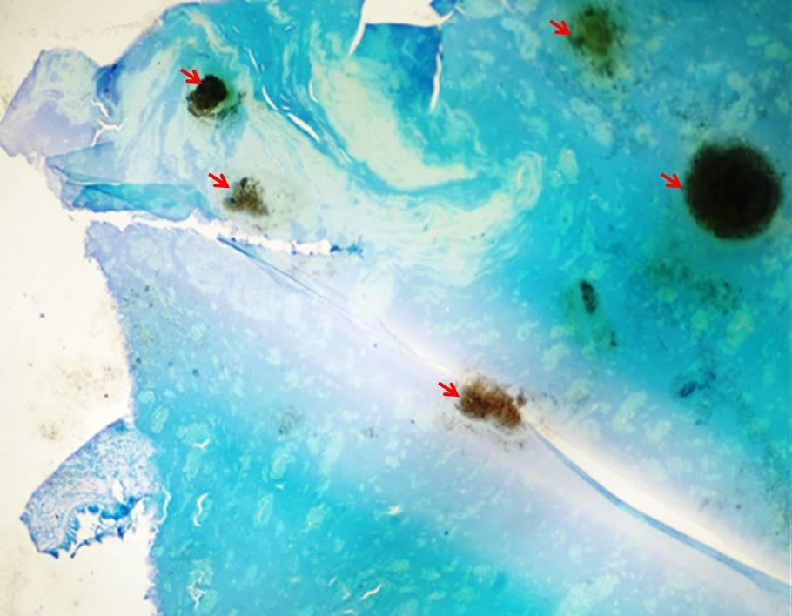
Fig 2: Allergic fungal rhinosinusitis (AFRS) showing eosinophilic mucin and fungal colonies (red arrows), GMS stain X100.
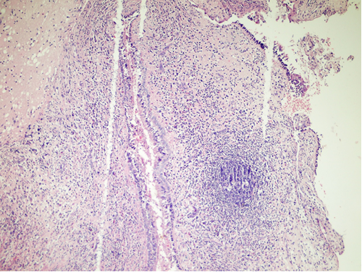
Fig 3a: Chronic rhinosinusitis with nasal polyposis (CRSwNP) showing inflammatory cells infiltrate with lymphoid follicle and pseudostratifiedcolumner ciliated epithelial covering H&E stain X100.
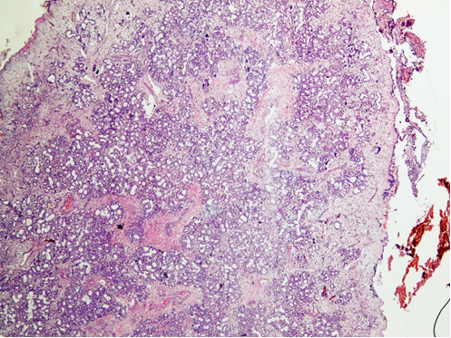
Fig 3b: Chronic rhinosinusitis with nasal polyposis (CRSwNP) showing hyperplastic mucous secreating glands in submucosa H&E stain X100.
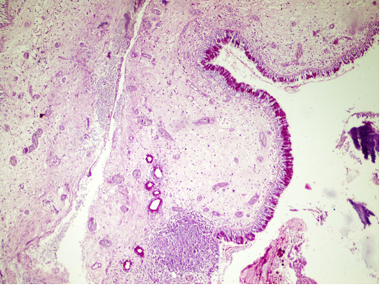
Fig 3c: Chronic rhinosinusitis with nasal polyposis (CRSwNP) showing inflammatory cells infiltrate with lymphoid follicle and pseudostratifiedcolumner ciliated epithelial covering. Note; no fungal hyphae, PAS stain X100.
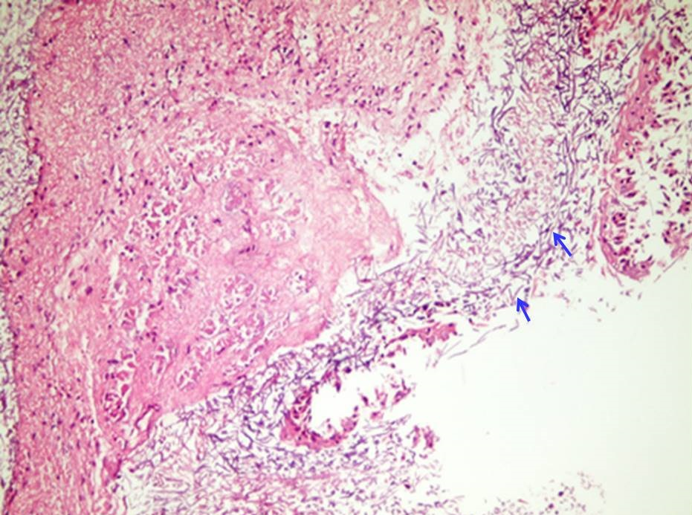
Fig 4a: Nasal polyp showing fungal hyphae on the mucosal surface (blue arrows). Note absence of AM, H&E stain X100.
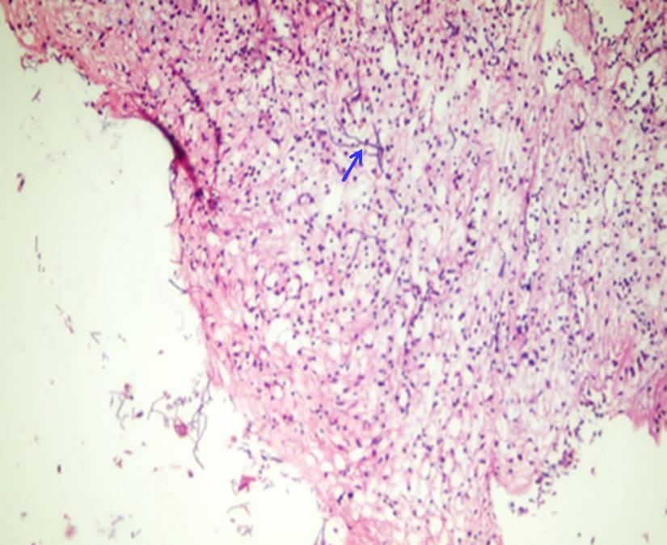
Fig 4b: Nasal polyp showing fungal hyphae invading the polyp tissue (blue arrow). Note absence of AM, H&E stain X200.
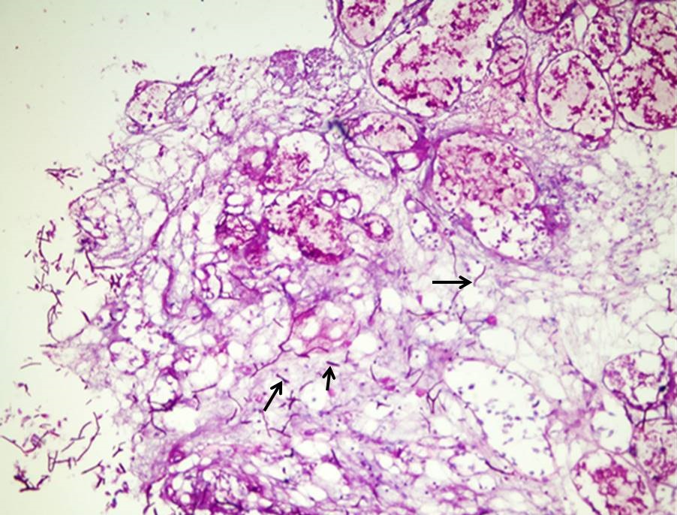
Fig 4c: Nasal polyp showing fungal hyphae invading the polyp tissue (black arrows). Note absence of AM, PAS stain X200.
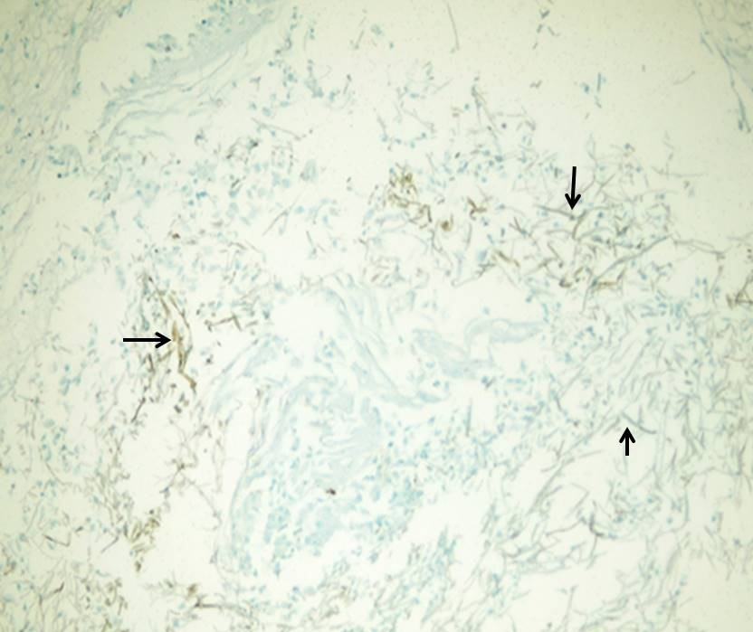
Fig 4d: Nasal polyp showing brown fungal hyphae invading the polyp tissue (black arrows). Note the absence of AM, GMS stain X100.

Discussion:
Allergic fungal rhinosinusitis is a noninvasive form of FRS. It is common among adolescents and young adults and is more common in geographical areas with high humidity like Southwestern states of the USA, Sudan, northern India, and Saudi Arabia.[12, 13, 14] Patients are often immunocompetent, 2/3 of patients are atopic and half suffer from asthma. Two-thirds of AFRS patients suffer from allergic rhinitis, and approximately 90% have increased blood levels of IgE.[9] In our study, all patients with AFRS were immunocompetent and young with a mean age at presentation of 22.39 years and 76.5% were in 2nd and 3rd decades of life with a range of 10-45 years, which is similar to that reported by DeShazo& Swain, and Schubert.[15, 13] It was believed that approximately 5-7% of patients with CRS suffer from AFRS but this diagnosis can be elusive. Classically, the diagnosis of AFS requires that 5 criteria are met as originally set by Bent and Kuhn. [16] However, there is no consensus in the literature regarding a uniform set of criteria. Many authors feel that lack of positive stains or fungal cultures does not rule out the diagnosis of AFS. In fact, the Bent and Kuhn criteria had been criticized. In their original criteria there was selection bias as all their patients presented with the 5 criteria but they did not evaluate others who did not have all 5 criteria. [17]
In the current study, 17/61 patients (27.87%) had double density sign in CT scan and were grossly identified to have AM within the nasal and sinus cavities at the time of endoscopic sinus surgery, in addition to nasal polyposis that alerted the surgeon to the possibility of AFRS. Unilateral polyposis was commoner among these cases (11/17=64.7%), contrary to bilateral disease that was commoner among all cases of nasal polyposis (49/61=80.3%). Similar to our finding, Bent &Pand Kuhn, Sohail et al., and Thahim et al. reported unilateral predominance in AFRS.[16, 18, 19] Thus, unilaterality of nasal polyposis raises the suspicion of AFRS.Histopathologically, AM was detected in all these 17 cases but only 5/17 of them (29.41%) were positive for fungal stains. The remaining 12/17 cases correspond to the recent description of eosinophilic FRS like syndrome or EMRS. These patients clinically behave like AFRS patients but do not demonstrate positive fungal stains.[20] One can say that detection of double density sign and bone erosion in CT, nasal polyposis and AM at endoscopic sinus surgery are not sufficient to diagnose AFRS. The diagnosis is only confirmed by finding fungal hyphae in AM or mucosal surface without tissue invasion. On the other hand, the mere finding of fungal hyphae in patients with nasal polyposis without detection of AM is not sufficient to diagnose AFRS. In our series, 2/61 (3.3%) patients demonstrated positive fungal stains on the mucosal surface of polyps and invading the tissue with no AM, confirming the diagnosis of CIFRS. Similar to our finding, John et al., in their study, found the association between nasal polyps and CIFRS. [21] Lara & Gomez mentioned that of the 400 cases reviewed during the 6-year time frame, a total of 25 (6.25%) cases with AM were identified. Of the 25 cases with AM, fungal organisms were identified in 10 cases. [2] They explained this by stating that the fungus might not necessarily be the initial cause of the disorder, but merely a later catalyst or an entrapped passenger/victim of an expansive process of proliferating tenacious and lamellated debris eliciting more production of AM. Kaur et al. also diagnosed AFRS clinically and radiologically in 35/75 of their cases. Allergic mucin was seen in all of these cases with statistically significant association, but fungal hyphae were detected in only 7/35 (20%) cases by PAS and silver stains.[9] The same finding was reported by Chandigarh who found that 15/130 of his AFRS cases were positive for fungal elements on histopathological examination.[22] Following such thought, we agree that consideration should be given to changing the name of the entity from AFRS to eosinophilic or allergic mucinrhinosinusitis.
The diagnosis of AFS remains a challenge. This might be due to either sparse presence of hyphae or failure of special stains to pick them up.[9] GMS detected fungal hyphae in all the 7 cases in our study (11.5% sensitivity), so GMS is much more superior to the PAS and H&E in the detection of fungal hyphae. Guo et al. (2012), in their study used a modification of GMS staining to improve the visualization of fungi in specimens. In addition, polymerase chain reaction is considered by some authors to be superior for fungal detection than fungal cultures. [24]

Conclusion:
No significant association between AM and fungal hyphae, only 5/17 (P=0.09) patients with AM fulfill the diagnostic criteria of AFRS. The presence of AM is not unique to AFRS, but rather is the result of a process that could have other etiologies. Allergic fungal sinusitis is more appropriately termed allergic mucinous sinusitis or eosinophilic mucinous rhinosinusitis. GMS is much more superior to the PAS and H&E in the detection of fungal hyphae.

Referances:
- Demir D, Süoğlu Y, Güven M, and Yılmaz MS. Prevalence of allergic fungal rhinosinusitis among patients with chronic rhinosinusitis with or without nasal polyposis who underwent endonasal sinus surgery in Northwestern Turkey. Kulak BurunBogazIhtisDerg. 2014; 24:259-264.
- Lara J and Gomez D. Allergic Mucin With and Without Fungus A Comparative Clinicopathologic Analysis. Arch Pathol Lab Med. 2001; 125:1442-1447.
- Stewart AE and Hunsaker DH. Fungus-specific IgG and IgE in allergic fungal rhinosinusitis. Otolaryngol Head Neck Surg. 2002; 127:324-32.
- Bakhshaee M, Fereidouni M, Mohajer MN, Majidi MR, Azad FJ and Moghiman T. The prevalence of allergic fungal rhinosinusitis in sinonasal polyposis. Eur Arch Otorhinolaryngol. 2013; 270:3095-4003.
- Collins MM, Nair SB and Wormald PJ. Prevalence of noninvasive fungal sinusitis in South Australia. Am J Rhinol. 2003; 17:127-159.
- Jain S, Das S, Gupta N and Malik JN. Frequency of fungal isolation and antifungal susceptibility pattern of the fungal isolates from nasal polyps of chronic rhinosinusitis patients at a tertiary care centre in north India. Med Mycol. 2013; 51:164-173.
- Ferguson BJ, Barnes L, Bernstein JM, Brown D, Clark CE, Cook PR, DeWitt WS, Graham SM, Gordon B, Javer AR, rouse JH, Kuhn FA, Levine HL, Manning SC, Marple BF, Morgan AH, Osguthorpe JD, Skedros D, Rains BM, Ramadan HH, Terrell JE and Yonkers AJ. Geographical variation in allergic fungal rhinosinusitis. OtolaryngolClin North Am. 2000; 33:441–449.
- Ferguson BJ. Eosinophilic mucinrhinosinusitis: a distinct clinicopathological entity. Laryngoscope. 2000; 110:799-813.
- Kaur R, Lavanya S, Khurana N, Gulati A and Dhakad MS. Allergic Fungal Rhinosinusitis: A Study in a Tertiary Care Hospital in India. Journal of Allergy. 2016; 1-7.
- Meltzer, EO, Hamilos DL, Hadley JA, Lanza DC, Marple BF, and Nicklas RA. Rhinosinusitis: establishing definitions for clinical research and patient care. J Allergy ClinImmunol. 2004; 114:155–212.
- Saravanan K, Panda NK, Chakrabarti A, Das A and Bapuraj RJ. “Allergic fungal rhinosinusitis: an attempt to resolvethe diagnostic dilemma,” Archives of Otolaryngology—Head and Neck Surgery. 2006; 132: 173–178.
- Gupta AK, Gosh S and Gupta AK. Sinonasalaspergillosis in immunocompetent Indian children. Mycoses. 2003; 46:455–16.
- Schubert MS. Allergic fungal sinusitis. OtolaryngolClin N Am. 2004; 37: 301-327.
- Panda NK, Balaji P, Chakrabarti A, Sharma SC and Reddy CE. Paranasalaspergillosis: its categrization to develop a treatment protocol. Mycoses. 2004; 47:277–83.
- DeShazo RD and Swain RE. “Diagnostic criteria for allergic fungal sinusitis” Journal of Allergy and Clinical Immunology. 1995; 96: 24–35.
- Bent J and Pand Kuhn FA. “Diagnosis of allergic fungal sinusitis”. Otolaryngol Head Neck Surg 1994;111(5):580-8.
- Luong A and Marple BF. Allergic fungal rhino-sinusitis. Cur Allergy Asthma Reports. 2004; 4: 465-470.
- Sohail MA, Al Khabori MJ, Hyder J and Verma A. Allergic fungal sinusitis: Can we predict the recurrence? Otolaryngol- Head Neck Surg. 2004; 131:704–714.
- Thahim K, Jawaid MA and Marfani MS. Presentation and management of allergic fungal sinusitis. J Coll Physicians Surg Pak. 2007; 17:23–30.
- Thompson and Lester DR. Allergic fungal sinusitis. In: John R. Goldblum, editor. Head and Neck Pathology: A Volume in Foundations in Diagnostic Pathology Series (Foundations in Diagnostic Pathology). London, Churchill Livingstone. 2006; 186-187.
- John P. and Frederick A. Allergic Fungal Sinusitis/Polyposis. Allergy and Asthma Proc. 1996; 17: 259-268.
- Das A, Bal A, Chakrabarti A, Panda N and Joshi K. “Spectrum of fungal rhinosinusitis; Histopathologist’s perspective”. Histopathology. 2009; 54: 854–859.
- Guo C, Ghadersohi S, Kephart GM, Laine RA, Sherris DA, and Kita H. improving the detection of fungi in eosinophilic mucin: seeing what we could not see before. Otolaryngol Head Neck Surg. 2012; 147:943-952.
- El-Morsy SM, Khafagy YW and El-Naggar MM. Allergic fungal rhino-sinusitis: detection of fungal DNA in sinus aspirate using polymerase chain reaction. J Laryngol Otol. 2010; 124:152-60.

